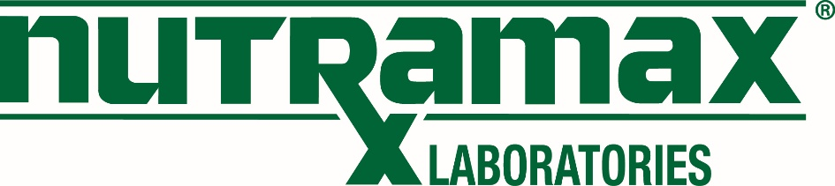

Effective: 8/27/2025

Team,
As a part of our ongoing efforts to maintain a consistent and professional image in all communications, this is a reminder that all employee email signatures must follow the Nutramax standard format.

Your email signature should include:
- Full name and title
- Phone number (and fax or mobile numbers, if pertinent)
- Company name
- www.nutramaxlabs.com (optional)
- Nutramax approved company logo (optional)
- Nutramax mailing address (optional)
- Nutramax social media links (optional)

Please refrain from adding anything additional to your signature line.
Thank you for helping us uphold a unified and professional brand presence.

Kristina Gordon
Vice President, Human Resources
Nutramax Laboratories
803-313-3940 – Phone
803-283-4258 – Fax
www.nutramaxlabs.com

